Working Group 1: Education systems in the digital age: The need for alignment

Discussion Paper

Group Leaders
Margaret Leahy, Assistant Professor of Education, Dublin City University, Ireland.
Peter Twining, Professor of Education (Futures), The Open University, UK.
Deirdre Butler, Professor of Education, Dublin City University, Ireland.

Group Members
- Ben Akoh. Canada
- Augusto Chioccariello. Italy
- Yousra Chtouki. Morocco
- Sara Farshadnia, Iran (not attending EDUsummIT)
- Sergey Grigorev. Russian Federation
- Leela Kansakar Pradhan. Nepal
- Kanda Moore. Thailand
- Roumen Nikolov. Bulgaria
- Carlos Pascual. Ethiopia (Philippines)
- Lucila Perez. Ecuador
- Amanda Sherman. USA
- Barbara Sherman. USA (Cambodia)
- Angel Smrikarov. Bulgaria
- Saunand Somasi. India
- Wanna Tienmee. Thailand
- Teemu Valtonen. Finland

Note: this is a working draft that is intended as a provocation and a starting point for our discussions. It is not intended to be a polished finished paper. Feel free to add comments and suggest changes. (Paper also available at: https://docs.google.com/document/d/1VkrkeXYS4nA4I7BcCLYAyzH79Gq1tl9gTDo9x-SnI6Q/edit)

Introduction
The focus of TGW1 is to explore the need for alignment across all aspects of education systems (specifically schools) to ensure that ICT is successfully used to support learning and that ultimately, education systems successfully prepare students to live, learn and work in the 21st century. The working group is thus concerned with two key questions;
- what is the purpose of education in a rapidly changing world, and thus what educational visions, policies and practices might be most appropriate and,

- how do we get alignment between educational visions/purposes, policies (e.g. curriculum), assessment and accountability systems, teacher learning and practice within (rather than across) education systems? In answering these questions, the attention of the group is directed exclusively on the schools sector (primary and secondary).
This discussion paper represents a starting point for the group which is comprised of 20 members representing 16 different nationalities. In this paper, we begin by stressing the importance of this theme to education and learning and make links between this paper and previous EDUsummIT reports. The importance of alignment and the need for alignment to be anchored within an appropriate vision for education is then articulated. This is followed by an account of the UNESCO framework (2008, 2008a, 2011) as this framework is the tool we propose the group uses to review and analyse the education systems within their various countries. Included as part of this section is a brief discussion of each of the aspects of the UNESCO framework and how it applies to one education system i.e. Ireland. The paper concludes by noting initial Implications and recommendations for researchers, practitioners, and policy makers as well as the key issues and questions to be discussed during the EDUsummIT 2017.
Group members have been asked to provide information about the education system in their country (or the country they are currently focussed on) to enable analysis of the extent to which there is alignment within each setting - these are available here.

Why is this theme important to education and learning?

At all levels, our education system is seeing the need to change to meet the challenges of a rapidly evolving digital society. The need to have a long-term vision for education that ensures that all students experience success and have the knowledge, skills, abilities and competencies to be successful in the 21st century was never more important.

Webb (1999) argued that lack of alignment between the components of an education system undermines the message about what is important in education, The importance of having alignment between education visions, policy and practice is well established (e.g. Butler et al, 2013; Fullan, 2013; Twining et al, 2013). However, what is less clear is what the purposes of education systems should be in a rapidly changing world, and thus what educational visions, policies and practices might be most appropriate. If we are to ensure that all students experience success and have the knowledge and personal attributes needed to be successful in the 21st century, the need to have a long-term purpose for education that was never more important.

What are the links between this paper and previous EDUsummIT reports?
The work of TWG1 is tightly linked with the ongoing work of EDUsummIT. Since its inception in 2009, working groups at EDUsummIT have explored a range of critical aspects relating to the use of ICT to support learning in the 21st century. For example, TWG1 has always had a focus on organisational change while TWG3 has focussed on teacher professional development highlighting the importance of aligning consistent educational visions with policy and practice (e.g. Twining et al., 2013). Similarly, at EDUsummIT 2015 TWG 7 in examining indicators of quality technology-enhanced learning stressed the importance of alignment.

While there was and remains need to explore and continue to build understanding of each of these individual areas, there is also need to stand back and explore if there is alignment between the various aspects in education systems i.e. to explore if and how all the parts of the ‘complex jigsaw’ work together to support the type of learning envisioned in the 21st century. If there is alignment, we need to ask what is the purpose/vision of that education system and does it meet the needs of its learners? If there is not alignment, we need to ask, why not and what could be done to achieve alignment?

What are the key issues and questions to be addressed during EDUsummIT 2017?

While the work of TWG1 focuses on the need for alignment of purpose, policy and practice across educational systems, critical to this conversation is understanding that what is defined as the purpose of education will inform alignment and determine if all students experience success and acquire the knowledge, skills, abilities and competencies to be successful in the 21st century. Key issues and questions to be addressed are thus as follows:

- The degree to which there is alignment in the education system (in your country)?
- What should the purposes of education be - what would an education system look like that was designed to achieve those purposes (vision)?
- To what extent do existing education systems match up to that vision?
- What do we know about how to achieve alignment?

Background
ICT has a key role to play in transforming education systems to meet the needs of the 21st century, not only because it changes many aspects of society which impact on the purposes of education, but also because it provides us with additional ways of supporting learners.

Lessons from the past demonstrate that the introduction of ICT into schools does not in and of itself lead to the development of innovative teaching practices or the transformation of education. If education systems are to support the type of learning envisioned in the 21st century, a ‘tinkering at the edges’ approach is not sufficient if we are to move towards a real transformation of education. Instead what is demanded is an understanding of how educational change can be empowered by digital technology and there is need to move beyond a sole focus on ‘ICT based innovations’ and reconsider the design of the whole school system so as to maximise the impact educational change will have. This implies the adoption of a more systemic, holistic approach to ensure the alignment of the key components of the system.

Mindful of Dewey’s (1934) advice that “any education is, in its forms and methods, an outgrowth of the needs of the society in which it exists”, questions of how best to shape a purpose or vision for education in the 21s century are critical to any conversation around the need for alignment. Key to all such conversations is the understanding that what is defined as the purpose of education will inform alignment and determine if all students experience success and acquire the knowledge, skills, abilities and competencies to be successful in this complex digital world. As a starting point to this conversation, we need to ask ourselves some difficult questions.

- Is our education system good enough to prepare students for a future none of us can predict?
- Will it ensure that our population has the ability to adapt, take on new roles and develop new opportunities?
- What role do digital technologies play in this? (Butler et al, 2013).

To answer these questions, we need to consider how we develop an educational system that is more enabling, empowering, supportive, and less prescriptive. In addition, how do we build a systemic approach into this learning eco-system which reflects the changing world while embracing the changing nature of technology and systematically exploring new technologies, all the time building towards a networked learning community that allows for enhanced collaboration, communication, and sharing? “Connectedness” on many levels and the development of networked learning communities within and across schools and society will be essential.

Framing the discussion
If education systems are to change to meet the needs of the 21st century, there is a need to consider the implications for all aspects of the education system. It must be realised that ICT is only one part of a complex jigsaw and the use of ICT to support the type of learning envisioned in the 21st century is challenging. If change is to occur and ICT successfully used to support learning, there is a need to consider the implications for all aspects of the education system. This includes policy goals and visions of education along with pedagogy, professional learning, curriculum, assessment, and school organisation and administration, all of which work together and reinforce each other as part of an interrelated and interdependent learning ecosystem.

The tool we propose the group uses to describe and analyse the education system within their various countries is the UNESCO framework (2008, 2008a, 2011). This framework could be useful to the working group as a “barometer” against which to review and interrogate what has been accomplished in countries to date and to provide indicators of what needs to be developed going forward.

The UNESCO framework (2008a, 2008b, 2011) (Figure 1).

Comprising six key aspects of a learning system, the UNESCO framework seeks to address the implications that different policy goals and visions of ICT may have for the other components of the education system: pedagogy, teacher practice and professional development, curriculum and assessment, and school organisation and administration. The framework also identifies three complementary, somewhat overlapping approaches that connect education policy with economic and social development: technology literacy, knowledge deepening and knowledge creation.

- Increase the technological skills of students, citizens, and the workforce by incorporating such skills in the curriculum—or the technology literacy approach.
- Increase the ability of students, citizens, and the workforce to use knowledge to add value to society and the economy by applying it to solve complex, real-world problems—or the knowledge deepening approach.
- Increase the ability of students, citizens, and the workforce to innovate, produce new knowledge, and benefit from this new knowledge—or the knowledge creation approach. (UNESCO, 2008, p.8)

Figure 1: The UNESCO Framework for ICT Policies to Transform Education
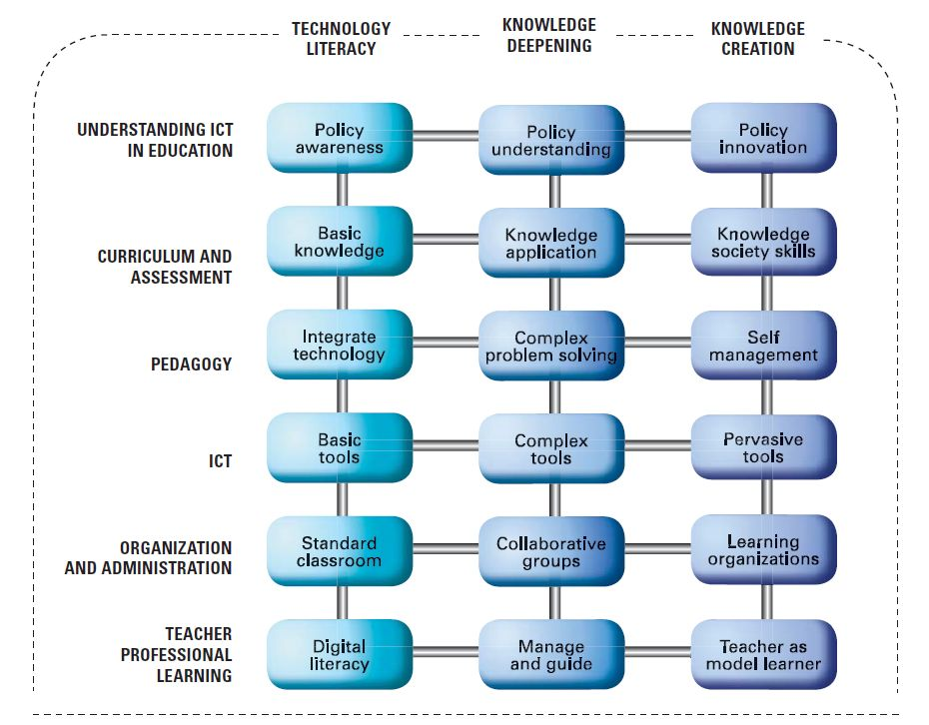
The likelihood in any education system is that the different components are more or less advanced and that the key to moving toward knowledge creation is to use current strengths as a lever to push forward other components of the system (UNESCO, 2008a, 2011). For example, as illustrated in Figure 2, the country represented in the spider diagram could leverage current strengths in teacher professional development and pedagogy to advance curriculum, assessment, and school organisation.
Figure 2. Diagram of Development Paths in the use of ICT in an Education System (UNESCO, 2011, p. 17)
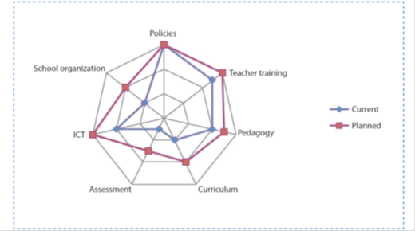

An example from Ireland
Using the UNESCO Framework (2011) and drawing on Butler et al. (2013) and Cosgrave, Butler, Leahy & Shiel (2014), what follows is a brief discussion of each of the six aspects of the UNESCO framework and how it applies to the education system in Ireland.

Understanding ICT in Education (Policy)
Without a shared vision to guide the national use of technology in education, ICT policy is only operational - it can become techno-centric, promoting the purchase of equipment and the organisation of teacher training without providing a strong educational purpose or goal for the use of technology (Kosma, 2008). There is also evidence to demonstrate that, in order for digital technologies to be effectively used in teaching and learning at school level, its use has to be part of the school vision and must be supported by specific national policies and strategies (Plomp et al., 2008; Shear et al., 2010a; Shear et al., 2011). This is already occuring in Ireland to a large extent. The use of digital technologies as an integral part of teaching, learning and assessment is endorsed in all recent educational policies and plans. The National Strategy to Improve Literacy and Numeracy among Children and Young People (2011-2020), (DES, 2011); Project Maths (NCCA, 2008), Key Skills Famework (NCCA, 2009) the Framework for the Junior Cycle (DES, 2011, 2012) and The School Self-Evaluation Programme (DES, 2012) all require that ICT is used as a part of student learning. In addition, the Irish Teaching Council has identifies ICT as a key national priority area (The Teaching Council, 2011).

ICT Infrastructure
An essential component towards the integration of ICT into schools is a robust infrastructure that provides teachers and students with relevant resources when and where they are needed. This includes resources such as computer hardware, data and networks, information resources, interoperable software and technical support. ICT infrastructure levels in schools and classrooms in Ireland are close to or exceed EU and OECD average levels. Most recent EU surveys (e.g. ESSIE, 2012; 2013; Eurydice, 2011) report that Ireland ranks close to or slightly above average across a range of indicators including computers ratios and Internet connectivity. In the 2013 ICT Census of Schools in Ireland, , the overall ratios of students to working computing devices were 4.6 to 1 at primary level, 3.7 to 1 at post-primary level, and 1.7 to 1 in special schools. However, the ratios of students to computing devices for student use were less-favourable– 11.1 at primary, 8.8 at post-primary, and 3.3 in special schools – reflecting a relative shortage of computing devices in schools for use by students. In addition, the issue of technical support for ICTs continues to concern schools. In the 2013 ICT Census, principal teachers ranked ‘insufficient level of technical support’ as a serious obstacle to the use of ICTs in teaching and learning in their schools. High-speed broadband was also ranked as a very high priority for their schools.

Curriculum and Assessment
Pedagogies associated with the use of ICT include those that emphasise high levels of understanding of key concepts within subject areas and the ability to apply these concepts to solve complex real-world problems (Bransford, Brown, & Cocking, 2000). Most recently, curriculum development initiatives emphasise “21st century skills” (often referred to as “Key Skills” or “Key Competencies”), (ETA, 2010; OECD, 2005; NCCA, 2008), qualities that prepare students to live and work in a digital society. They include skills such as critical thinking and problem solving, communication, collaboration, self-regulation and information management (Binkley et al., 2012; Partnership for the 21st Century, 2003, 2005). The ability to use technology effectively and reflectively is identified as a key competence in each of these initiatives. Each initiative stresses the potential of digital technologies to transform student learning experiences by helping students become engaged thinkers, active learners, knowledge constructors and global citizens to participate fully in society and the economy (DES, 2015).
In Ireland, as highlighted in the 2013 ICT Census, the range of purposes for which teachers most frequently use ICTs focus mainly on presenting information in class, accessing curriculum-relevant online resources for lesson preparation, and using applications to prepare resources for class. These response patterns are indicative of a more traditional view of learning, where ICTs are used to strengthen existing teaching and learning practices, rather than as learning tools in the service of 21st century skills. The data also indicate many teachers have been slow to embrace ICT-driven assessment tools and are likely to lack the knowledge and skills to implement ICTs effectively in ways that engage and challenge students (e.g. social networking, web 2.0 tools). In contrast recent curriculum developments such as the Framework for the Junior Cycle at Secondary level (DES, 2012) reflects the shift towards collaborative problem solving and higher-order thinking, driven by the productive use of digital technologies. It identifies as a learning statement that the student “uses technology and digital media tools to learn, communicate, work and think collaboratively and creatively in a responsible and ethical manner” (p. 6).

Assessment
Assessment reform emphasises the need for alternative and continuous assessment that is integrated into regular, ongoing instructional activity (Kosma, 2008). ICT-supported student assessment is an emerging area (Bakia et al., 2011; Binkley et al., 2012; Eurydice, 2011; EACEA/Eurydice, 2009). As of yet, technology-supported assessment is not widely used and there is a lack of evidence on actual classroom and school use of ICT for assessment purposes (Redecker, 2013). Where used, ICT mainly supports summative assessment although interest in formative and diagnostic assessment is growing, and recent efforts have focused on assessing higher-order skills such as problem solving in collaborative settings. In a landmark paper on technology-supported assessment Binkley et al. (2012) specify in detail the components of 21st century skills, and how such skills, including complex problem solving, communication, team work, creativity and innovation, can be assessed using technology. They argue that 21st century assessments should: be aligned with the development of important 21st century goals; incorporate adaptability and unpredictability; be largely performance-based; add value for teaching and learning; make students’ thinking visible; be technically sound; and generate information that can be acted upon and provide productive and usable feedback for all intended users.
In Ireland, the dialogue around ICT-supported assessment is just beginning.

Pedagogy
The concept of teaching and learning through the use of ICTs is highly complex. The introduction of ICT into a learning environment does not in and of itself bring about change in pedagogical practice. Rather, its use in education is inextricably linked with understandings of the nature of knowledge and the nature of knowing. If we accept that all teaching, either explicitly or implicitly, is informed by a philosophy of teaching and learning (Becker, 2000; Bransford, Brown & Cocking, 2000; Cuban, 1993, Jones and Mercer, 1993, Becker and Riel, 1999), it follows that there is a relationship between teachers’ general philosophical beliefs about teaching and learning, their pedagogical practices, and their use of ICT.
Research studies have repeatedly demonstrated that a teacher‘s pedagogical orientation is a dominent factor in how they use ICT in their classroom (e.g. Law et al., 2008; Plomp et al., 2009; Shear et al., 2010; Shear et al., 2010a; Shear et al., 2011). For example, a critical finding from the SITES 2006 study (Law et al., 2008) was that ICT adoption per se did not determine or change pedagogocal orientation in education systems. In fact, in countries/regions such as Hong Kong and Italy, ICT-using practices exhibited a stronger traditional orientation. Research has also consistently demonstrated that computer-based interventions tend to be more effective when combined with constructivist approaches to teaching, rather than with more traditional approaches (e.g. Becker, 2000; Li & Ma, 2010; Sandholtz, et al., 1997).
In Ireland, survey reports that while most teachers have been familiar with ICT for teaching and learning for some years, they use it first and foremost to prepare their teaching and for teacher presentation during lessons to explain information and concepts. Few teachers use ICT to work with students during lessons and, where they do, the range of ICT use is limited (Conway & Brennan, 2009; Cosgrove & Marshall, 2008; DES, 2008; European Schoolnet and University of Liege, 2013; Cosgrave et al., 2014). What these data suggests is that, for the most part, the use of ICT in schools is at the technology literacy level (UNESCO, 2008, 2008a, 2011). What this implies is that teachers use ICT in computer laboratories or in classrooms with limited facilities to complement standard curriculum objectives, existing assessment approaches and traditional teaching methods (UNESCO, 2008).

Teacher Professional Learning
Teachers in today’s classroom must not only be prepared to use technology but must also know how to use technology to support student learning. According to UNESCO, these have become “integral skills in every teacher’s professional repertoire” (2008, p.1).
The emphasis in many countries for quite some time has been on developing technology literacy. Professional development programmes in the area of technical skills have been more readily available than pedagogically-oriented ones (Plomp et al, 2009). There are concerns that models of professional development which focus on technical competences without pedagogical context is ‘retooling’ teachers for specific tasks, rather than engaging in pedagogy of a substantial nature (Watson, 2001). It is therefore not surprising to note that the two most commonly reported national priorities for teacher development programmes reported across 21 countries in the International Experience with Technology in Education (IETE) study (Bakia et al, 2011) were:
- supporting teachers’ integration of ICTs into instruction
- improving teachers’ pedagogical skills
In Ireland, initial ICT policy initiatives (e.g. IT2000, Blueprint for Education, 2001) focussed on “upskilling” teachers with basic “ICT competencies”. However, since the mid-2000s, this focus has shifted and subsequent professional development programmes have been designed with the goal of developing teachers’ technological literacy and emphasise the pedagogical use of basic ICT tools in the curriculum subjects. Priorities for teachers’ continuing professional development (CPD) identified by principal teachers and teachers in the 2013 ICT census included the use of ICT as a teaching and learning tool across the curriculum and use of ICT to support the development of key skills such as literacy and numeracy Principal teachers at all levels prioritised ICT-related CPD facilitated by external tutors over other forms of delivery. The interest in literacy and numeracy reflects its current emphasis as a national priority.

Organisation of Learning/ Designing Learning Spaces
Changing pedagogical practices necessitates a corresponding appraisal of how learning spaces are conceptualised. This is imperative to enable the enquiry-based, collaborative nature of learning described previously. It can be enabled through the use of flexible and adaptable digitally-based resources and systems that provide high-quality learning opportunities with flexible timing and pacing through a range of learning environments. This will entail changes to the existing conceptions of timetabling and how learning is organised. It will also have implications for how teachers interact with one another and the relational roles/ responsibilities of teachers and students
In Ireland, the design of learning spaces can for the most part be described as traditional.
Figure 3. Spider Diagram mapping Primary sector in Ireland. The concentric levels correspond to each of technology literacy, knowledge deepening and knowledge creation. As illustrated in the diagram, although policies, pedagogy, curriculum and approaches to assessment are at or towards the knowledge deepening level, ICT infrastructure, teacher professional learning and the organisation of learning are at the technology literacy level.

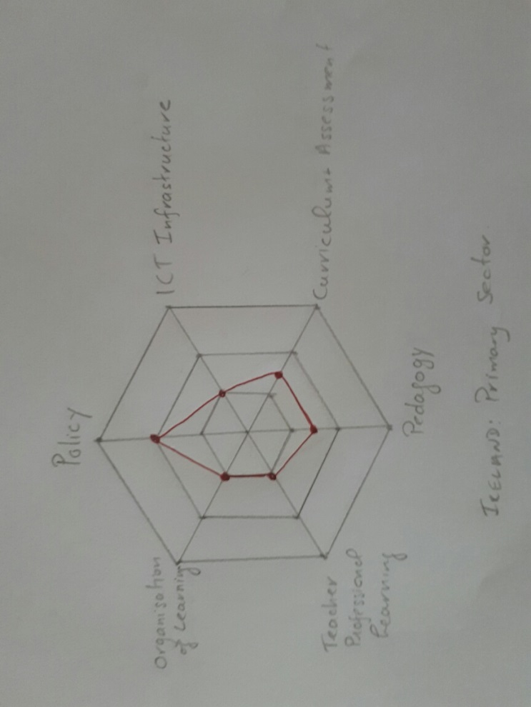

Implications and recommendations for researchers, practitioners, and policy makers
If the challenge is to develop effective education systems, fit for purpose to meet the needs of individuals in society today and in the future, what are the research, policy, and practice challenges and what are your recommendations to help stakeholders move forward?

The group will explore key issues and questions (which are summarised below).

Key recommendations: it is too early to say what these might be as they are likely to be a core outcome from the discussions. However, we anticipate that we will be arguing that we need to have an integrated and holistic view of our education system, because looking at elements in isolation is not effective. Thus, the focus shouldn’t be on ‘how to integrate ICT’, but rather on the purposes of education, educational vision, and the degree to which all the elements of the system work together towards that vision. In addition, we may be making recommendations about core elements that should be present in educational visions for the 21st century.

Key issues and questions to be discussed during the EDUsummIT 2017
- What do we mean by alignment? (See http://edglossary.org/alignment/)
- Does alignment matter? (Hopefully we can reach rapid agreement that it does!)
- What are the key elements that need to be aligned with each other? (Our starting suggestion is that they are: educational vision; curriculum, assessment and accountability regimes; pedagogical practice (which if we take a broad view of pedagogy would include consideration of the physical and temporal structuring of schools)
- To what extent is there alignment between vision, policy and practice in the countries we have information for?
- What does the data from different countries tell us about how to achieve alignment
- What should the purposes of education be in our rapidly changing world? Is there any common purpose that we could all agree was critical - if so what would it be? (We are suggesting that the key common factor would be the need to enhance lifelong learning in order to adapt to a changing world)

References
Bakia, M., Murphy, R. Anderson, K. & Trinidad, G. (2011). International experiences with technology ‎in education: Final report. U.S. Department of Education, Office of Educational Technology and the ‎Office of Planning, Evaluation and Policy Development, Policy and Program Studies Service. Retrieved November 26 2013 at: ww2.ed.gov/about/offices/list/os/technology/iete-full-report.doc
Becker, H. (2000). The "exemplary teacher" paper -How it arose and how it changed its author's research program, Contemporary Issues in Technology and Teacher Education 1 (2). Retrieved November 26 at: http://www.citejournal.org/vol1/iss2/seminal/article2.htm
Becker, H & Riel, M. M. (1999), Teacher professionalism and the emergence of constructivist Compatible pedagogies. Paper presented at the American Educational Researchers Association. Retrieved November 26 at: http://www.crito.uci.edu/TLC/findings/special_report2/index.htm
Binkley, M., Erstad, O., Herman, J., Raizen, S., Ripley, M., & Rumble, M. (2012). In P. Griffin, B. McGaw & E. Care (Eds.), Assessment and teaching of 21st century skills (pp. 17-66). Dordrecht: Springer+Business Media.

Conway, P. & Brennan, E. (2009). National policies and practices on ICT in education (pp. 383-402). In T. Plomp, N. Law & J. Pelgrum (Eds.) (2009). Cross-national information and communication technology. Policies and practices in education. Charlotte, North Carolina: Information Age Publishing.

Cosgrove, J., & Marshall, K. (2008). ICT access and usage in Irish primary schools: Identifying the gaps. Dublin, Ireland: Liffey Press.
Cosgrove, J., Butler, D., Leahy, M., Shiel, G., Kavanagh, L., Creaven, A., (2014). The 2013 ICT Census in School Report.

Butler, D., Leahy, M., Shiel, G., & Cosgrove, J. (2013). Building towards a learning society: A national digital strategy for schools. Dublin: Educational Research Centre.

Department of Education and Science. (2015). Digital Strategy for Schools 2015-2020 Enhancing Teaching Learning and Assessment. Dublin: Author.Retrieved: https://www.education.ie/en/Publications/Policy-Reports/Digital-Strategy-for-Schools-2015-2020.pdf (Accessed September 3 2017)

Department of Education and Science (DES). (2008). ICT in Schools. Inspectorate Evaluation Studies. Retrieved November 26 at: http://www.education.ie/en/Publications/Inspection-Reports-Publications/Evaluation-Reports-Guidelines/ICT-in-Schools-Inspectorate-Evaluation-Studies.pdf

Dewey, J. (1934). Individual psychology and education. The Philosopher 12,

European Schoolnet and University of Liege. (2013). Survey of schools: ICT in education. Benchmarking access, use and attitudes to technology in Europe’s schools. Final Report (ESSIE). Brussels: European Union. Retrieved November 26 2013 at: http://ec.europa.eu/digital-agenda/sites/digital-agenda/files/KK-31-13-401-EN-N.pdf

Fullan, Michael. Stratosphere: Integrating technology, pedagogy, and change knowledge. Pearson Canada, 2013.

Kozma, R. (2008). Comparative analyses of policies for ICT in education (pp 10883-1096). In J. Voogt & G. Knezek (eds.), International handbook of information technology in primary and secondary education. Berlin: Springer Science.

Plomp, T., Law, N. & Pelgrum, J. (Eds.) (2009). Cross-national information and communication technology. Policies and practices in education. Charlotte, North Carolina: Information Age Publishing.

Redecker, C. (2013). The use of ICT for the assessment of key competences. European Union, Luxembourg: Publications Office of the European Union. Retrieved November 26 at: http://ftp.jrc.es/EURdoc/JRC76971.pdf

Sandholtz, J. H., Ringstaff, C., & Dwyer, D. C. (1997). Teaching with technology: Creating student centered classrooms. New York: Teachers College Press.

Twining, P. (2014) Rethinking schooling for the 21st century. 17th UNESCO-APEID International Conference, 28-31 Oct 2014, UNESCO: Bangkok (Thailand). https://www.researchgate.net/publication/268130678_Rethinking_schooling_for_the_21st_century (accessed 9-Feb-2017)

Twining, P., Raffaghelli, J., Albion, P. & Knezek, D. (2013) Moving education into the digital age: the contribution of teachers’ professional development. Journal of Computer Assisted Learning, 29, pp.426-437. doi: 10.1111/jcal.12031 http://onlinelibrary.wiley.com/doi/10.1111/jcal.12031/full (accessed 9-Feb-2017)

UNESCO (2008). ICT competency standards for teachers: Competency standards modules. Paris: UNESCO. Retrieved November 26 at: http://unesdoc.unesco.org/images/0015/001562/156207e.pdf.

UNESCO (2008a). ICT competency standards for teachers: Policy framework. Paris: UNESCO. Retrieved November 26 at: http://unesdoc.unesco.org/images/0015/001562/156210E.pdf.

UNESCO (2011). ICT competency standards for teachers: Policy framework. Paris: UNESCO. Retrieved November 26 at: http://iite.unesco.org/pics/publications/en/files/3214694.pdf
Webb, N. L. (1999). Alignment of science and mathematics standards and assessments in four states (Research Monograph No. 18). Washington, DC: Council of Chief State School Officers.

Recommended readings
For an analysis of alignment between curriculum, assessment & accountability regimes, and practice in primary schools, comparing state and independent schools in England and one state school in Scotland see pp.159 to 169 of Twining et al. (2017) NP3 – New Purposes, New Practices, New Pedagogy: Meta-analysis report. London: Society for Educational Studies. http://edfutures.net/images/e/e7/NP3_Meta-analysis_report.pdf (accessed 30-Aug-2017)

Butler, D., Leahy, M., Shiel, G., & Cosgrove, J. (2013). Building towards a learning society: A national digital strategy for schools. Dublin: Educational Research Centre. https://www.education.ie/en/Schools-Colleges/Information/Information-Communications-Technology-ICT-in-Schools/Digital-Strategy-for-Schools/Building-Towards-a-Learning-Society-A-National-Digital-Strategy-for-Schools-Consultative-Paper.pdf (Accessed September 3 2017)

